North Hills Preparatory

Incoming 2nd Grade

Summer Reading Assignment

2024-2025

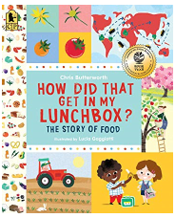

* [*How*](http://www.arbookfind.com/bookdetail.aspx?q=83273&l=EN&slid=38775282) *Did That Get In My Lunchbox? The Story of Food*

(Chris Butterworth)

ISBN**-13:** 978-0763665036

Welcome to Second Grade!

We are so excited to start our year with you. The pages after this are your summer reading assignments. Please read both books and complete the following:

1. After reading, *How Did That Get In My Lunchbox?,* create your own plate with foods you like to eat!
2. Have fun creating your plate by following the directions on the next page.
3. After reading a non-fiction book of your choice and on your reading level, complete the non-fiction graphic organizer. The organizer is on the page below.
4. Bring the completed non-fiction graphic organizer and the plate you created to school. **These assignments are due the first day of school.**

You can print out this packet at [www.northhillsprep.org](http://www.northhillsprep.org).

Have a great summer and we will look forward to a great year with you this fall!

The Second Grade Team

[***How***](http://www.arbookfind.com/bookdetail.aspx?q=83273&l=EN&slid=38775282) ***Did That Get In My Lunchbox? The Story of Food***

1. Read the book several times - it is really a fun book!

2. Make a list of foods you like to eat. Be a thinker! Try to think about your favorite foods from each food group!

3. Next, design your plate. Using a paper or plastic plate works best! You can glue pictures of food, draw pictures of food, or glue play food to your plate.

You will **bring your completed plate on the first day of school**, and use it as a tool to tell your new friends and teacher all about what you like to eat.  We can’t wait to see it!

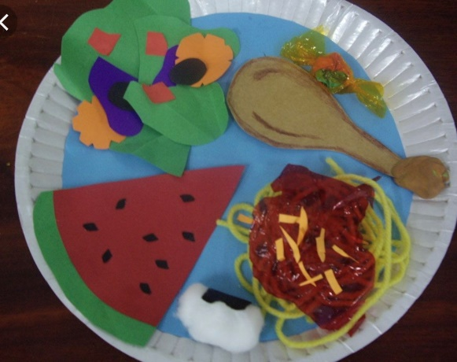 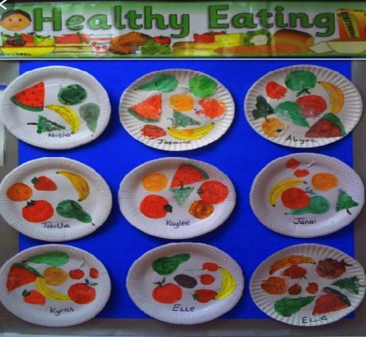

***********************************************************

Parents,

Please keep this project simple. We want this to be scholar created. Students can use construction paper, play food, stickers of food, draw pictures of food, print out pictures to put on the plate, or any other material. Do **not** use real food.

Name: ___________________

**Non-fiction Reading**

|  |
| --- |
| **Title of Book:** |
| **Author:** |

**I learned about… Three things I learned…**

**Text Feature Find:**

Find one **bolded** word and give its definition: ________________________________________________________________________________________________________________________________________________________________________________________________________________________

Find a caption and copy it below:

________________________________________________________________________________________________________________________________________________________________________________________________________________________